Appendix 7: Supporting Materials for Recommendation #7

Online Resources Associated with SSU’s General Education Program
- Information about the GE reform process can be found here: http://ge.sonoma.edu/about
- The fall 2018 Senate presentation on intentional GE and signature assignments is accessible here: https://senate.sonoma.edu/sites/senate/files/sigassign_senate_presentation.pdf
- The complete narrative for the seawolf experience can be found here: https://catalog.sonoma.edu/content.php?catoid=5&navoid=615
- The final approved version of the GE program is posted here: https://ge.sonoma.edu/resources
- GE learning outcomes are posted online: https://ge.sonoma.edu/student-learning-outcomes and in the online catalog: https://catalog.sonoma.edu/content.php?catoid=5&navoid=615
- The curriculum map for the GE program is available here: https://ge.sonoma.edu/sites/ge/files/images/grid_gelo_curriculum_map_.pdf
- Course content criteria for all areas of GE, including first-year and sophomore-year experiences, can be found halfway down this webpage: https://ge.sonoma.edu/resources
- Information about the GE assessment process is posted here: https://ge.sonoma.edu/assessment

General Education Flow Map
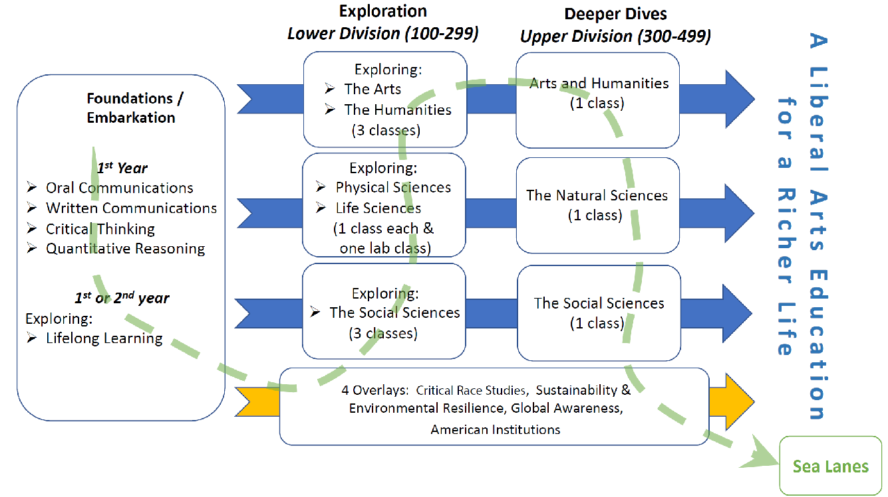

Online Resources Related to Graduate Programs
- The May 2019 graduate studies subcommittee report to the academic senate is available here: https://senate.sonoma.edu/sites/senate/files/gss_graduate_education_report_may2019.pdf
- The graduate studies website is accessible here: https://academicaffairs.sonoma.edu/academic-programs/graduate-studies
- The redesigned graduate degree programs website can be found here: https://www.sonoma.edu/academics/degree-programs

Proposed Graduate-Level Learning Goals from Graduate Studies Subcommittee
(Note: Developed by Graduate Studies Subcommittee (GSS) in March 2020. Still needs to be approved by senate.)

The graduate-level learning goals at Sonoma State University are derived from and approved by all graduate programs on campus. They are used to distinguish the graduate level educational experience at Sonoma State University and were approved by the GSS on March 5, 2020. The goals incorporate the strategic priorities of the campus including: student success, academic excellence, leadership cultivation, and transformative impact.

Graduate Level Learning Goals
Disciplinary Knowledge: Expand mastery of a field of knowledge, both foundational and specific.
Critical Thinking/Analysis: Demonstrate advanced skills of creative, analytical and critical thinking.
Communication: Demonstrate advanced oral and written communication skills.
Practical Application: Engage with practical and professional aspects of the field, such as research, projects, or professional experience.
Professional Integrity: Demonstrate advanced knowledge and skills related to cultural and ethical aspects of the field.
Integrative Dimension: Engage with competencies that integrate cultural, technological, ethical, practical, and/or professional aspects of the field.

Online Resources Related to Faculty Engagement in Setting SLOs and Standards
- The GE assessment process is described here: https://ge.sonoma.edu/assessment
- SSU’s recently revised internship policy can be found here: http://www.sonoma.edu/policies/internship-policy
- SSU’s syllabus policy is available here: http://www.sonoma.edu/policies/syllabus-policy

Online Resources Related to a Reimagined and Reinvigorated Student Affairs Division
- The student affairs division’s purpose and mission is located here: https://studentaffairs.sonoma.edu/
- The student affairs division’s organization chart can be found here: https://studentaffairs.sonoma.edu/organizational-chart
- The website for where to access resources for specialized populations is available here: https://advising.sonoma.edu/where-seek-advising
- The LARC website can be found here: http://web.sonoma.edu/writingcenter/
- The MAVRC’s website is here: http://studentsuccess.sonoma.edu/mavrc
- Detail about CARE can be found at this website: https://studentaffairs.sonoma.edu/care-students-concern
- Information on the basic needs initiative is located here: https://studentaffairs.sonoma.edu/basicneeds
- Information on the seawolves lead program is located here: https://getinvolved.sonoma.edu/seawolveslead-connect-educate-empower
- Details on the MESA program are available here: http://scitech.sonoma.edu/mesa

Community Learning Framework Draft

