Appendix 6: Supporting Materials for Recommendation #6

Definition of Central Terms and Concepts
The following are definitions that guide diversity, equity, campus climate, and inclusion efforts.
Diversity entails individual differences (e.g., personality, prior knowledge, and life experiences) and group/social differences (e.g., race/ethnicity, class, gender, sexual orientation, country of origin, and ability, as well as cultural, political, religious, or other affiliations). (Source: https://www.aacu.org/making-excellence-inclusive)
Equity [in education] refers to the principle of fairness. While it is often used interchangeably with the related principle of equality, equity encompasses a wide variety of educational models, programs, and strategies that may be considered fair, but not necessarily equal. It has been said that “equity is the process; equality is the outcome,” given that equity—what is fair and just— may not, in the process of educating students, reflect strict equality—what is applied, allocated, or distributed equally. (Source: https://www.edglossary.org/equity/)
Equity-Mindedness refers to the perspective or mode of thinking exhibited by practitioners who call attention to patterns of inequity in student outcomes. These practitioners are willing to take personal and institutional responsibility for student success, and critically reassess their own practices. It also requires that practitioners are race-conscious and aware of the social and historical context of exclusionary practices in American higher education. Source: https://cue.usc.edu/about/equity/equity-mindedness/)
Campus Climate is defined as the current attitudes, behaviors, and standards of faculty, staff, administrators and students concerning the level of respect for individual needs, abilities, and potential. (Source: https://diversity.universityofcalifornia.edu/policies-guidelines/campus-climate.html)
Inclusion [depends on a sense of belonging that] connotes full membership in the [campus] community. This entails success in achieving not merely formal participation but also rewarding participation for all members of a diverse campus community in the opportunities, resources, and decision-making structures of the campus. Because membership entails not only rights but also responsibilities...success requires that each of us understands how he, she, or they contribute to crafting this community, to supporting academic excellence, to fostering individual well-being, and to respecting each other’s dignity. (Source: https://inclusionandbelongingtaskforce.harvard.edu/files/inclusion/files/harvard_inclusion_belonging_task_force_final_report_full_web_180327.pdf)

Highlights from SSU’s Diversity Timeline
- 1967 - 1980: A federally-funded Multi-Cultural Center was established.
- 1970s - 2008: Inter-Cultural Center, renamed mid-1990s as the Center for Culture, Gender, and Sexuality.
- 1970s – early 1990s: EOP high school outreach program; Women’s Resource Center.
- 1980 - present: Affirmative Action, first as a faculty release, then as a director in Academic Affairs, and now a function of HR in Administration and Finance.
- 1998: Campus conducted two climate diversity surveys.
- 2001-2002: The Provost established a Diversity Task Force charged to draft a “Diversity Vision Statement,” which met in 2002 to “discuss implementation” of the vision statement.
- 2008: The President established the President’s Diversity Council; Faculty Senate formed an Ad Hoc Task Force on Diversity, later renamed the Senate Subcommittee on Diversity.
- 2012: A successor to the earlier Multicultural Center was renamed the HUB and assigned a director. The mission of the HUB is “community-building” and its focus is cultural programming for students.
- 2013: A faculty member from the School of Science and Technology is appointed Director of Diversity.
- 2017: SSU became the 22nd CSU campus to quality as a Hispanic Serving Institution. Title V funding established PUERTA for Latinx students.
- 2017: The President responded to requests from the Black Student Union for more resources addressing underrepresentation on campus with a formal institutional response that included a timeline for concrete action in areas such as hiring and housing.
- 2017: Graduation Initiative funding provided funding for positions, centers, and leadership for undocumented, first-generation, and low-income students. Scholarship programs were established or expanded for children of migrant wine-country workers.
- 2018: Human Resources rolled out required implicit bias training for staff and manager recruitments.

Theoretical Framework for DEI Work at SSU
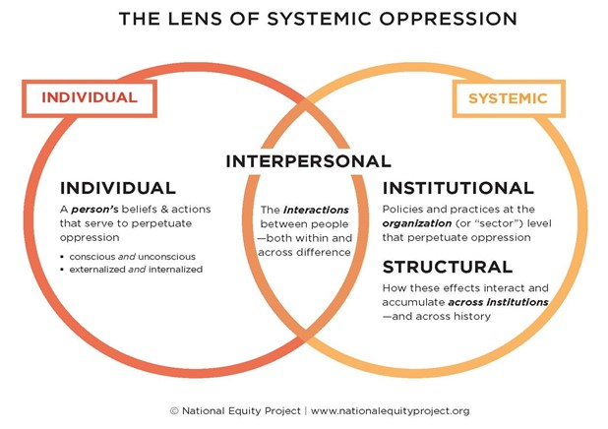

Online Resources Associated with Justice, Equity, Diversity, and Inclusion at SSU

- SSU’s diversity, equity, and inclusion website is available here: http://diversity.sonoma.edu/
- SSU’s 2013 statement on civility and tolerance can be found here: https://senate.sonoma.edu/resolutions/resolution-support-ssu-statement-civility-and-tolerance
- SSU’s August 2019 campus equity report is available at this website: https://academicaffairs.sonoma.edu/sites/academicaffairs/files/2019_campus_equity_report_-_sonoma.pdf
- The student affairs division’s diversity statement is available at this website: http://studentaffairs.sonoma.edu/division-student-affairs-diversity-statement
- Residential education and campus housing (REACH)’s commitment to equity, diversity, and inclusion can be found here: https://housing.sonoma.edu/about/equity-diversity-and-inclusion
- The student health center’s diversity statement can be found here: http://health.sonoma.edu/about/consumer-information/mission-diversity
- The SDS’s charge is described at this website: http://senate.sonoma.edu/memberships-and-meeting-dates/academic-senate
- The senate’s diversity vision statement resolution can be found here: http://senate.sonoma.edu/resolutions/sonoma-state-university-diversity-vision-statement-0
- The school of arts and humanities dean’s message on protests and justice is available here: https://ah.sonoma.edu/node/139
- The school of business and economics (SBE) has had an inclusive excellence task force since fall 2017. The SBE’s commitment to inclusive excellence is described here: http://sbe.sonoma.edu/about/inclusive-excellence
- The school of education’s social justice-focused mission and vision is available here: http://education.sonoma.edu/about

Examples of Justice, Equity, Diversity, and Inclusion Programs at SSU

- SSU’s center for community engagement describes its diversity and social justice efforts here: https://cce.sonoma.edu/initiatives-and-programs/diversity-and-social-justice
- SSU’s statements on addressing racial injustice and a call to action can be found here: https://cce.sonoma.edu/initiatives-and-programs/address-racial-injustice
- The basic needs initiative strategic planning document is available here: http://studentaffairs.sonoma.edu/sites/studentaffairs/files/u85/bni_strategic_plan_2025_-_01.13.20__1.pdf
- Student resources to address food and housing insecurity can be found here: http://as.sonoma.edu/basic-needs
- In October 2019, SSU hosted a diversity-focused forum for prospective graduate students with recruiters from over 150 universities as described here: https://www.sonoma.edu/calendar/norcal-forum-diversity-graduate-education
- Information on the wine industry scholars program (WISP) is available here: https://sbe.sonoma.edu/scholarships
- Publicity about the first cohort of WISP students is posted here: http://sbe.sonoma.edu/news/wine-industry-scholars-program-awards-150000-first-generation-university-students
- SSU is an academic alliance member of the National Center for Women in Information Technology (NCWIT), which has specific, measurable goals with respect to the retention of women in IT majors. SSU report numbers to NCWIT, and participates in their programs. For example, in the school of science and technology, a women in technology group was formed for female students in computer science, electrical engineering, and physics: https://scitech.sonoma.edu/wit. Also, SSU has participated in the “Sit With Me” project, which encourages women in computing careers: https://scitech.sonoma.edu/wit/sit-with-me

Campus Diversity Inventory
To provide a snapshot of SSU’s diversity efforts, the PAC conducted an inventory of all diversity-related programs on campus. The results showed that SSU has 438 initiatives in support of diversity, equity, and inclusion, spread across campus units as follows:

SSU Unit | Number of Diversity-related Initiative/Programs
Academic Affairs | 50
Academic Senate | 6
Administration and Finance | 12
Associated Students | 26
Green Music Center | 14
Student Affairs | 326
University Advancement | 4

Basic Needs Support for Students
In December 2019, the student affairs division finalized a basic needs initiative to advance equitable opportunities for access and success in the pursuit of an SSU degree. This supports SSU’s student success strategic priority by promoting and encouraging student well-being and engagement as essential for active learning and educational success, strategically building on and amplifying basic needs initiatives, and advancing programs, services, and partnerships that promote holistic support both in and out of the classroom. The initiative targets many areas of basic need including food, housing, and financial insecurity.

