Appendix 3: Supporting Materials for Recommendation #3

Online Resources Associated with SSU’s Strategic Planning Process
- SSU’s strategic plan is viewable on this webpage: http://strategicplan.sonoma.edu/building-our-future-ssu
- An overview of the strategic planning process is available at: http://strategicplan.sonoma.edu/process/overview
- The strategic planning task force membership list is provided here: http://strategicplan.sonoma.edu/process/strategic-plan-task-force
- Details on the guiding principles, goals, process, and support for the strategic planning process are located here: http://strategicplan.sonoma.edu/process/strategic-plan-process
- Details on the share, shape and unite phases are available at: http://strategicplan.sonoma.edu/process/overview
- The seawolf commitment can be viewed here: http://web.sonoma.edu/seawolfcommitment/index.html
- Data from the strategic planning process is located here: http://strategicplan.sonoma.edu/process/data
- Information on the world cafés can be found here: http://strategicplan.sonoma.edu/process/timeline/world-cafes
- The timeline for the strategic planning process is available here: http://strategicplan.sonoma.edu/process/timeline
- The strategic priorities are available at this link, along with the measurable goals and tactics developed by each of SSU’s divisions: http://strategicplan.sonoma.edu/priorities
- The strategic plans for all divisions are located here: http://strategicplan.sonoma.edu/progress
- The list of 2018-19 accomplishments by academic affairs units is posted here: https://academicaffairs.sonoma.edu/sites/academicaffairs/files/academic_affairs_accomplishments_v2_19.06.19.pdf
- The list of 2019-20 accomplishments by academic affairs units is available here: https://academicaffairs.sonoma.edu/sites/academicaffairs/files/2019-20_academic_affairs_accomplishments_final.pdf
- SSU’s budget and planning home page can be found here: https://budget.sonoma.edu/; see documentation of budget forums provided to the campus.
- Interactive dashboards related to the campus budget and all other budgeted funds are located here: https://sonoma.openbook.questica.com/

Strategic Plan Terminology
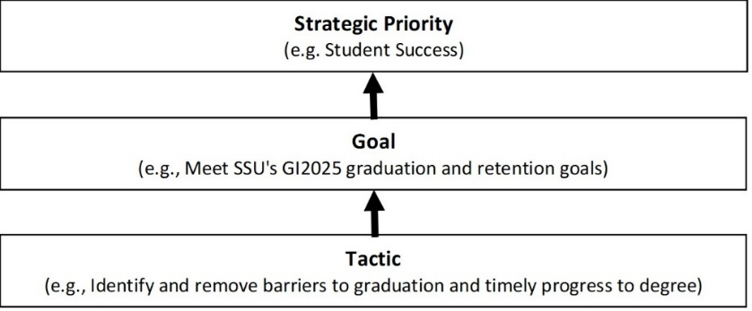

Instructions for Participants at the Launch Event for the Strategic Planning Process
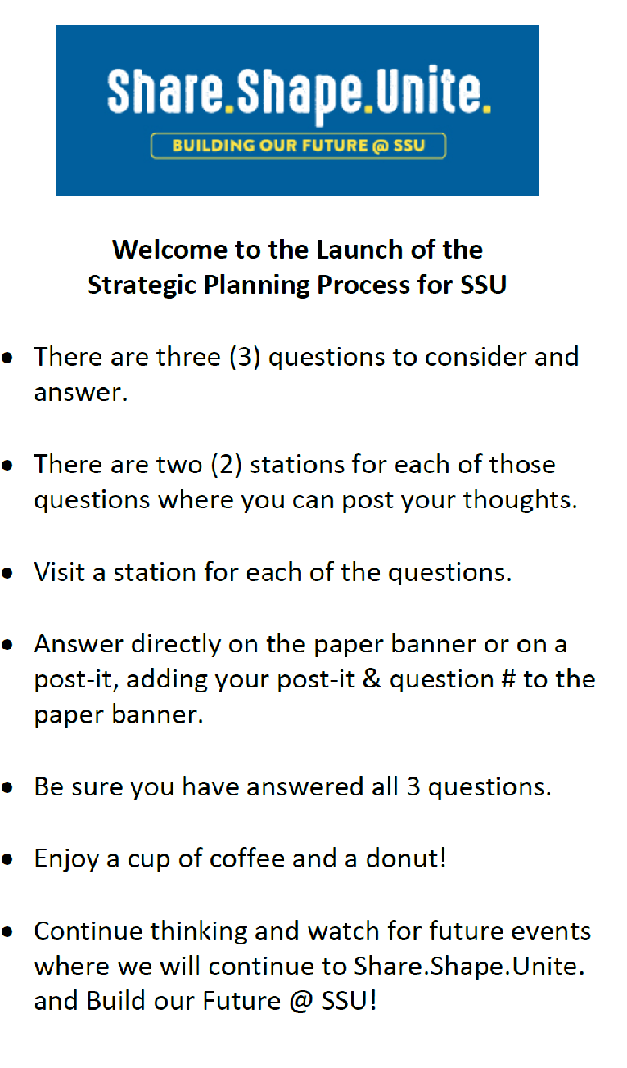
Questions Posed at Launch Event
What do you love about SSU?
What would you like to see @ SSU that we do not have now?
Fill in the blank: “In the future, I hope that SSU ______________.”

Questions Asked at World Cafés
- Sustainability and Environmental Inquiry: We have heard that sustainability and environmental inquiry are important to SSU. In five years, where do you see SSU in the area of sustainability and environmental inquiry?
Prompts to ask after people have answered the initial question:
  - What is the potential impact SSU can have in this area?
  - What opportunities exist for SSU to enhance this work?
  - What are some ways we can get others excited about sustainability in SSU?

- Diversity and Inclusive Excellence: Diversity and inclusive excellence are very important to the SSU community. This includes our support of supporting a diverse community of students, faculty, and staff, as well as supporting diversity awareness in our broader community. What can SSU do to strengthen our support for diversity and inclusive excellence?
Prompts to ask after people have answered the initial question:
  - What can SSU do to strengthen diversity awareness in our broader community?
  - How could we measure our progress in the area of diversity and inclusive excellence over time?

- Community Engagement and Partnerships: It is clear that we have a lot of pride about SSU’s strong community partnerships and also there is an opportunity to grow in this area. What types of programs and partnerships do you think SSU needs to develop in order to be relevant to the community? [Examples could include internships, symposia, leadership networks, bigger presence in the community, etc.].
Prompts to ask after people have answered the initial question:
  - What is the potential impact of SSU creating a greater sense of presence in the community?
  - In five to seven years, how do you see SSU’s role in the community and where are we most successful in community partnership?

- Academic Excellence: Continuing to be a leader in academic excellence for both undergraduate and graduate programs is very important to SSU. What could we be known for now and, if you think in 5-7 years, what do we want to be known for?
Prompts to ask after people have answered the initial question:
  - In the same time period, what have we done to keep up with emerging trends in education?
  - What does academic excellence look like to you?
  - What opportunities exist for SSU to step up and continue this work and rank in excellence?

- Interdisciplinarity and Innovation: We have heard that developing more opportunities for interdisciplinarity and innovation at SSU is important to our stakeholders. What do you think SSU can do to encourage more interdisciplinarity and innovation to support the emerging educational needs and prepare students to solve real-world problems?
Prompts to ask after people have answered the initial question:
  - How can SSU continue to think and work across disciplines?
  - What opportunities exist for SSU to enhance and strengthen this work?

- Social Justice: Social justice has been emphasized as an important value to SSU. What do you think social justice means to SSU?
Prompts to ask after people have answered the initial question:
  - What opportunities do you see for SSU to enhance and continue this work?
  - How can SSU be a hub for social justice in the next 5-7 years?

- Global Awareness and Citizenship: We have heard that it is very important for SSU students to learn to be globally informed and understand our interconnected world. What does global awareness and citizenship look like to you?
Prompts to ask after people have answered the initial question:
  - What opportunities do you think we can or should create for our students to learn about global engagement and global citizenship?
  - In five to seven years, how could we measure whether we have strengthened our commitment to global awareness and global citizenship?

- Campus and Physical Resources: During our interactions with SSU students, leaders and community, we have heard frequently that SSU has a beautiful physical campus and incredible environmental preserves. If you think of potential future opportunities for SSU to grow and innovate, what does the future of our campus look like to serve the mission and vision?
Prompt to ask after people have answered the initial question:
  - Can you identify specific campus needs for SSU to remain relevant and be innovative in the future?

Examples of the data gathered during the strategic planning process
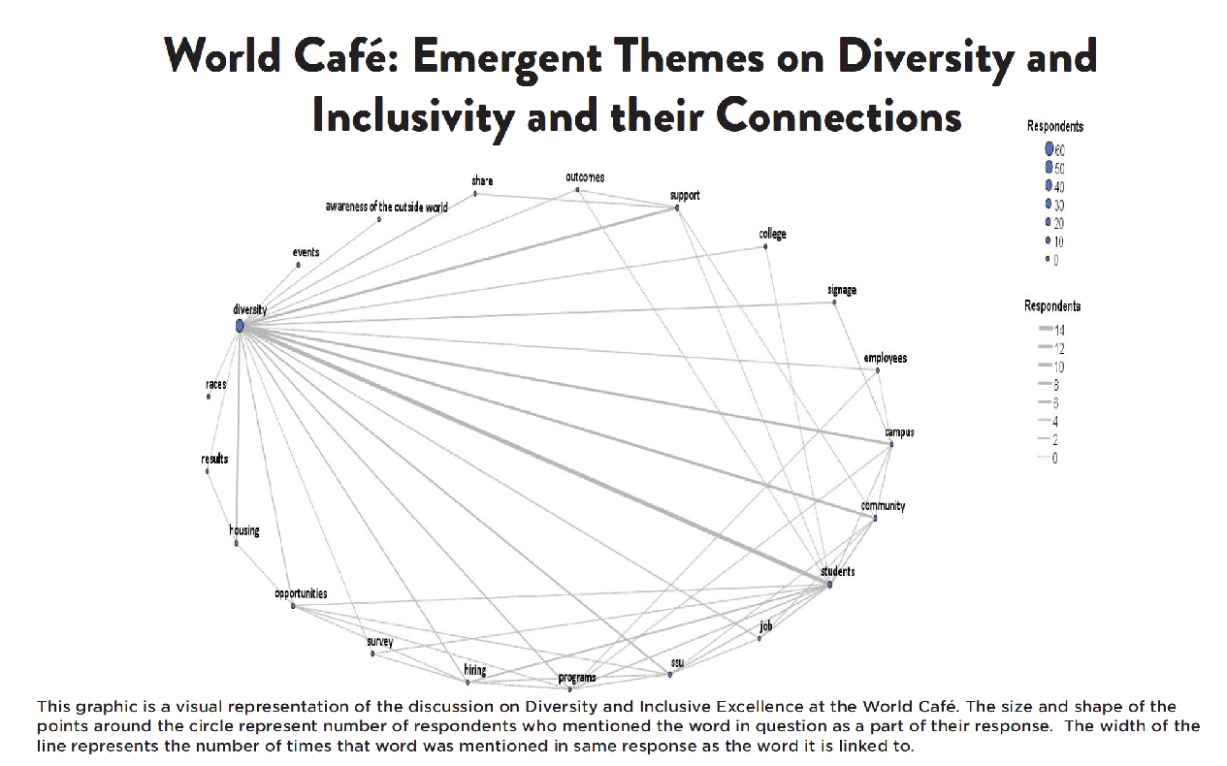

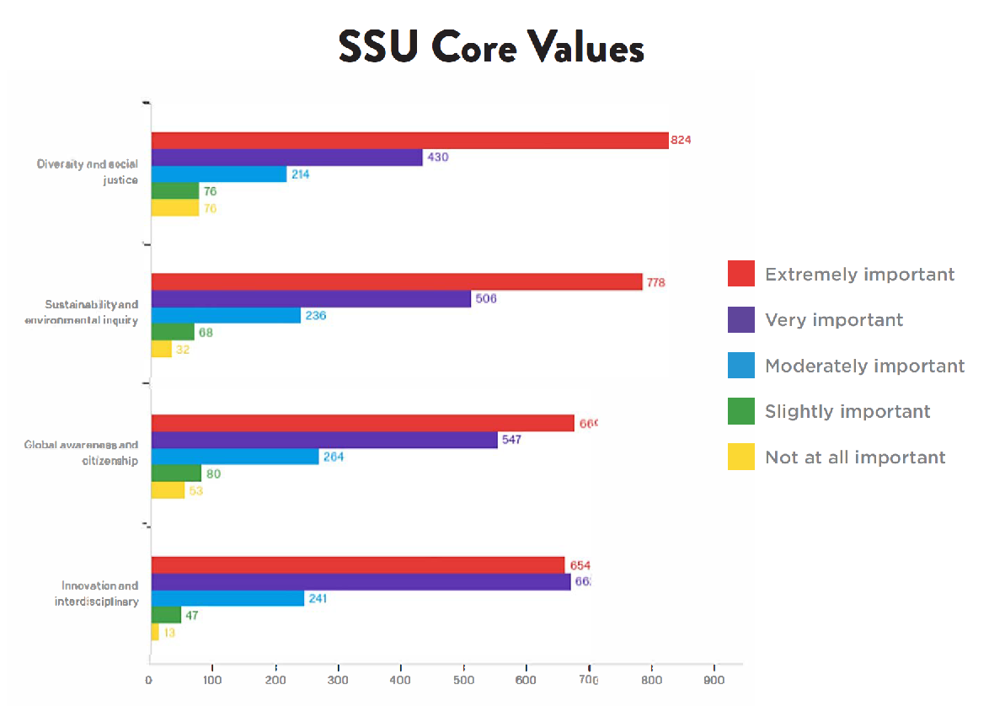

Strategic Plan “Blocks”
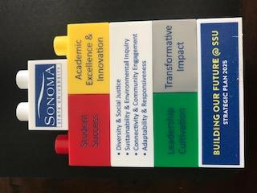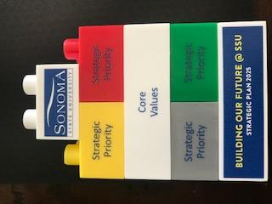
Example of a Smartsheet for Tracking Progress on Strategic Goals
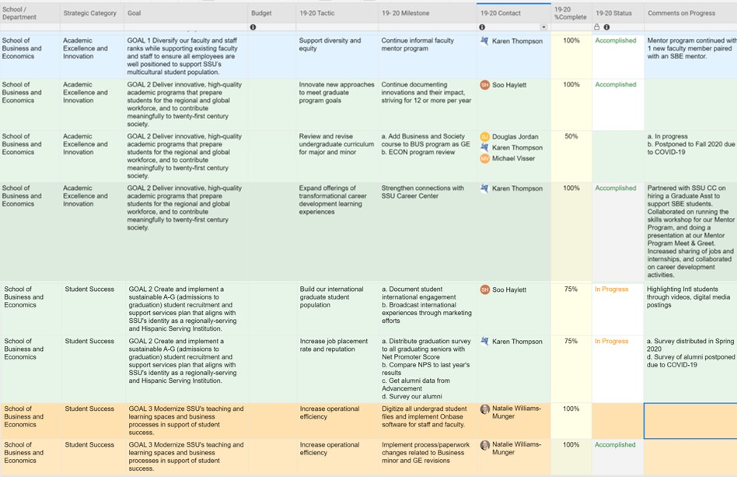

Strategic Budgeting Directions for Campus Units for 2020-21 Planning
Budget Call Part One – Section Two: Link to Strategic priorities
Please use the Qualtrics link below to provide a narrative as to how your unit’s budget plan
meets division and campus strategic priorities. https://sonoma.az1.qualtrics.com/jfe/form/SV_01g91ZXIagqmQrb

Budget Call Part Two: 2020-2021 Strategic Planning Tactics
Please use the link above to complete your 2020-21 Strategic Planning Tactics in Qualtrics. It is that time of the year as you are planning your budgets to also update your strategic plan tactics for the 2020-2021 year. Units may have already planned out tactics for the 2020-21 year as a part of Division/unit strategic planning, you do not need to enter your comprehensive strategic plan as it may be more than three to five tactics. Please just enter three to five S.M.A.R.T. Tactics which highlight your link between your planned budget and the strategic plan.
S: Specific - What, why, and how
M: Measurable - Include metrics to measure success of the goal
A: Achievable - Must possess the appropriate knowledge, skills and ability to achieve the goal
R: Results focused - Should measure outcomes, not activities
T: Time bound - goals should be linked to a time frame

Strategic Budgeting Description Sent to Faculty
Sonoma State University has been transitioning from its previous budget model to a new strategic budgeting model and we want you to know more about the progress we have been making and what it means for the campus.

Previous Budget Model
Our previous budget model was an incremental budget approach meaning that allocations were made every year as an increase or decrease to the funding provided the year before. In the previous budget model, funding was provided mainly by top down and centralized decision making. Most budget line allocations were not fully reviewed for impact on an annual basis and the budget process was largely ad hoc and reactive. The budget planning process focused on a single year and it was difficult for campus constituents to get information on how the budget decisions were made on campus. This model allowed for efficient and expedient budget allocation decisions but did not encourage a broad, strategic approach to campus resource planning.

New Budget Model: Strategic Budgeting
There was lots of room for improvement in how we manage budget on campus so in implementing the new strategic budgeting model, we are looking to address many of the concerns under the previous budget model. Strategic budgeting is the process of creating a multi-year budget that incorporates assessment to link planning and budgeting. It is a continuous process that allows us to invest in our institutional assets such as our people, programs and plant and to fund our shared campus priorities.
The campus Strategic Budgeting model remains an incremental budget approach but otherwise varies dramatically from our previous campus budget model. Strategic budgeting intentionally links the resource allocation process to the campus planning process and delegates more decision making to the Major Budget Units, adding a bottom up component to the budget planning process. Strategic budgeting is a proactive budget model, looking forward towards the next budget year rather than planning for the current year, as well as working towards building multi-year budgets. Linking planning to the budget also allows the model to be more proactive and transparent to the campus about how budget decisions are made. As with all budgets, there will always be hard choices to make but tying our resource allocation model to our campus strategic plan ensures that our priorities are funded first.

New Model: Strategic Budgeting | Previous Model
Linked to the Strategic Plan | Ad hoc
Proactive | Reactive
Bottom Up and Top Down Budget Line Allocations | Top Down Budget Line Allocations
Multi-year | Single Year
More Decisions Delegated to Major Budget Units | Centralized Decision Making
Highly Transparent | Difficult to Understand How Decisions Were Made

Linking Planning and Budgeting
So, what does this actually look like in practice? So far, the campus has made several steps to operationalize strategic budgeting. Creating rational policies around budget was the first important step. The President’s Budget Advisory Committee has reviewed and recommended two policies for Presidential approval: the University Reserve Policy and the University Budget Oversight Policy. Both policies set standards for campus processes that guide decision making towards efficient use of our resources and effective planning.
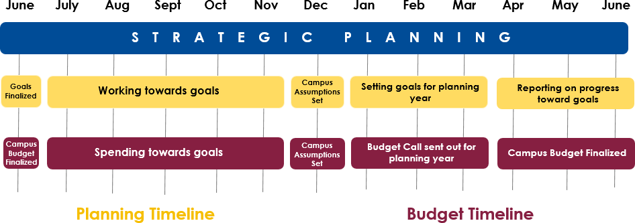
Next, we worked to re-align our campus budgeting timeline and implemented the first annual Budget Call in which we asked each Division to review their budget for next year while at the same time outlining their goals and explaining how those goals and resources are connected and will move the campus priorities forward. The campus budgeting timeline now aligns with State and Chancellor’s Office budgeting timelines and with our new campus planning timeline. Rather than finalizing our budget during the year we are already spending it, units are now planning ahead for the next fiscal year, setting priorities and goals at the same time they are considering what resources will be available to them. The campus budget will then be finalized by the beginning of the fiscal year. This change also helps set the stage for multi-year budget planning.

Strategic budgeting is allowing the campus to address issues that were not as easily managed in the previous model because we were considering only one fiscal year at a time. This has allowed us to move forward several major campus priorities such as faculty and staff equity and numerous technology improvements like e-transcripts and LoboConnect. One of the prime examples of how strategic budgeting is having a tangible impact on teaching and learning on campus is with the classroom renovations initiative. Faculty and students express regular concern about the conditions of our general assignment classrooms. As part of the Academic Affair strategic plan, a goal is to create and maintain twenty-first century teaching and learning classrooms that promote student success and active learning spaces. A tactic to achieve this goal is the classroom renovations initiative and to move this initiative forward, the Provost is investing $3 million to bring our classrooms to the standards being developed by the Academic Senate. A classroom condition survey is being developed by APARC to ensure that we monitor and maintain these standards. Both faculty and student feedback is being solicited as part of this process to ensure that we create spaces that promote active learning. The investment in classroom renovations is an excellent illustration of strategic budgeting in action.
We still have a lot more left to do! We plan on expanding which campus funds are budgeted, so that we move towards an ‘all funds’ budget approach. We are going to move from a one-year budget to a formalized multiple year budget and provide more public facing budget reports. During next year’s Budget Call, units will be asked to assess how well they did on their stated goals from the first year and begin to create metrics to track their progress on their goals, and we will continue to improve upon the work that we have already begun.

How Can You Help?
It is important for everyone on campus to think strategically about our campus resources. As you think of new opportunities to pursue, consider the campus strategic priorities as well as those of your Division and School. Talk to your Dean and Chair about how your work helps to advance campus goals and contribute to desired outcomes. As a campus, we came together to build our strategic vision, and it is important that we all work together to make it a reality. Strategic budgeting is the roadmap that is going to lead us there!

