Appendix 1: Supporting Materials for Recommendation #1

Online Resources Associated with PLOs and Assessment Plans
- Guidelines for degree programs doing program reviews are available at this website: https://academicaffairs.sonoma.edu/academic-programs/program-review/self-study
- The slides associated with the formal training provided to programs who are starting the program review process are accessible here: https://academicaffairs.sonoma.edu/academic-programs/program-review
- Points to guide discussions between programs and UPRS are provided at this link: https://academicaffairs.sonoma.edu/academic-programs/program-review/subcommittee
- Examples of recent program reviews with their PLOs and assessment plans can be found here: https://academicaffairs.sonoma.edu/academic-programs/program-review/schedule
- The GE revision process is described here: https://ge.sonoma.edu/about
- GE student learning outcomes are listed at this website: https://ge.sonoma.edu/student-learning-outcomes
- SSU’s revised GE program and other resources are available here: https://ge.sonoma.edu/resources

Example of an Assessment Plan
The bachelor’s degree program in Communication and Media Studies provided an example of a well-developed assessment plan in its 2018 program review. The full self-study can be found at this website: https://academicaffairs.sonoma.edu/academic-programs/program-review/schedule. The course map from that self-study is shown below.

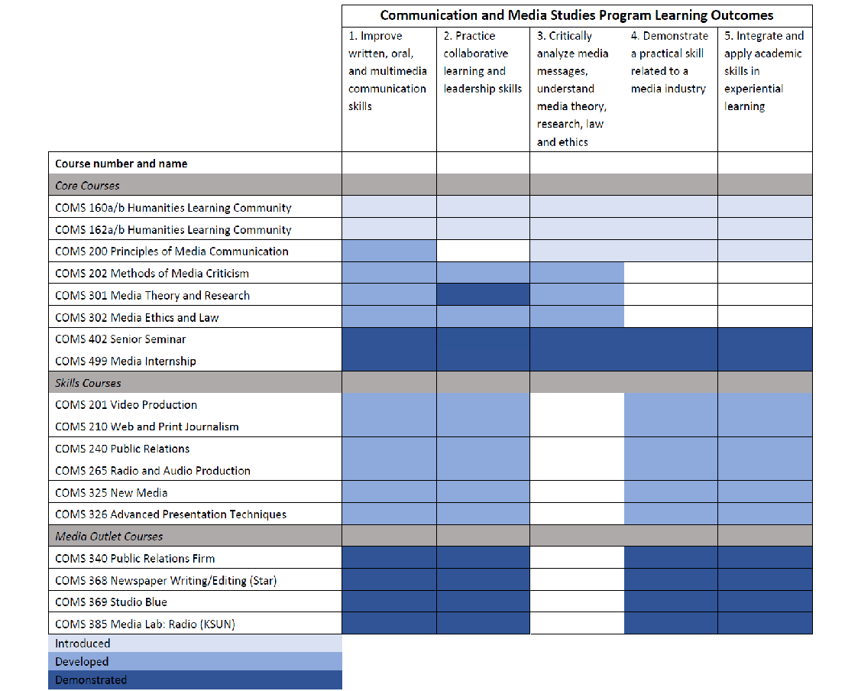

GE Program Learning Outcomes
Sonoma State's GE program has 13 student learning outcomes designed to provide Seawolves with an intentional, coherent, inclusive undergraduate experience across multiple disciplinary perspectives. The program fosters broad transferable skills and integrated, engaged learning that positions students to create and participate meaningfully and ethically in our interconnected and interdependent world.
Upon completion of GE coursework, Seawolves will be able to:
- Actively analyze texts in a variety of forms, genres, and disciplines (Critical Reading)
- Iteratively formulate questions for research by gathering diverse types of information; identifying gaps, correlations, and contradictions; and using sources ethically toward a creative, informed synthesis of ideas (Information Literacy)
- Advance cogent and ethical arguments in a variety of genres with rigor and critical inquiry (Argument)
- Communicate clearly and eloquently in written, oral, and/or performative forms in a variety of genres and disciplines (Communication)
- Interpret, evaluate, and employ quantitative analysis and arguments (Quantitative Reasoning)
- Identify, interpret, and apply methods, intellectual approaches, and fundamental concepts from disciplines within the social sciences, natural and physical sciences, arts, and humanities (Disciplinary and Interdisciplinary Knowledge)
- Synthesize and apply theoretical and practical perspectives from multiple disciplines to develop an understanding of complex issues (Integration)
- Attain and apply knowledge of social power and difference in relations between self, other people, and social structures locally and nationally while honoring contributions of people of different identities (Diverse Cultural Competencies)
- Drawing on the past and present, develop knowledge and skills that promote active citizenship, with the capacity to deliberate, act, and lead in a democratic society (Civic Responsibility)
- Explore past and present relationships among humans and between societies and environments and create new ways to cultivate a more secure and resilient future for all of our planet (Sustainable Development)
- Develop knowledge of past and present political, economic, and cultural relations operating at international to global scale (Global Awareness)
- Apply knowledge, skills, and multiple perspectives in new situations to analyze and formulate solutions to complex problems with confidence and creativity (Creative Problem Solving)
- Produce new work through performance, design, construction, art, or creative writing that is characterized by innovation, divergent thinking, and intellectual risk taking (Creative Expression)
The GE student learning outcomes (GELOs) align with the campus strategic plan, the CSU chancellor's office policy (formerly EO 1100), as well as SSU's distinctive identity as a liberal arts institution. They provide the program with a tool to guide learning and programmatic improvement. These outcomes are measured through annual assessment efforts in order to ensure the campus' commitment to quality education.
[Note: Information above is all posted on this website: https://ge.sonoma.edu/student-learning-outcomes]

